NAME : VANDANA.M
ROLL NO : 241801306
WEB TECHNOLOGY AND MOBILE APPICATIONS
Week 2 Lab Programs

Program 1: Develop and demonstrate the usage of Inline, Internal and External style sheet using CSS

Aim
To design a Online Internship Information poratal web page and demonstrate the usage of:
- Inline CSS
- Internal CSSss
- External CSS

Software Required
- OS: Windows / Linux
- Editor: VS Code / Notepad++
- Browser: Chrome / Firefox

Theory
CSS (Cascading Style Sheets) is used to control presentation of HTML elements such as:
- Colors
- Fonts
- Layout
- Spacing
Types of CSS:
- Inline CSS – applied directly inside an HTML tag
- Internal CSS – written in <style> tag inside <head> section
- External CSS – written in a separate .css file and linked using <link> tag

Steps / Procedure

A) Inline CSS
- Open VS Code / Notepad++.
- Create a new file and save as inline.html.
- Write basic HTML structure for the Internship Portal.
- Apply CSS directly inside tags using the style="" attribute.
- Example: style="color: blue; text-align: center;"
- Save the file.
- Open inline.html in a browser.
- Verify that styles are applied inside individual elements (title, description, button).

B) Internal CSS
- Create a new file and save as internal.html.
- Write basic HTML structure for the Internship Portal.
- Inside <head>, add a <style> ... </style> block.
- Write CSS rules for elements like:
- body, h1, p, button
- Save the file.
- Open internal.html in browser.
- Verify that styles are applied through internal stylesheet.

C) External CSS
- Create a new file and save as external.html.
- Create another file and save as style.css in the same folder.
- In style.css, write CSS rules for:
- body, h1, p, button
- Save both files.
- Open external.html in browser.
- Confirm webpage formatting is applied from external file.

Program Code
A) Inline CSS Example

File: inline.html
<!DOCTYPE html>
<html>
<head>
<title>Online Internship Portal - Inline CSS</title>
</head>
<body style="background-color:#f0f8ff; font-family:Arial;">
<h1 style="color: #0066cc; text-align: center; font-size: 36px;">
Online Internship Information Portal
</h1>

<p style="font-size: 18px; color: #009933; text-align:center;">
Welcome to our Internship Portal. Explore opportunities with top companies!
</p>

<button style="background: linear-gradient(#ff9933, #ff6600);
padding: 12px 20px;
border: none;
border-radius: 6px;
color: white;
font-size: 16px;">
View Internships
</button>
</body>
</html>
B) Internal CSS Example

File: internal.html
<!DOCTYPE html>
<html>
<head>
<title>Online Internship Portal - Internal CSS</title>
<style>
body {
font-family: 'Segoe UI', sans-serif;
background: linear-gradient(to right, #e6f7ff, #ffffff);
margin: 0;
padding: 0;
}
h1 {
color: #cc0066;
text-align: center;
padding: 20px;
font-size: 40px;
}
p {
font-size: 18px;
color: #333;
text-align: center;
margin: 20px;
}
button {
background-color: #0066cc;
color: white;
padding: 12px 25px;
border: none;
border-radius: 8px;
font-size: 16px;
display: block;
margin: 0 auto;
cursor: pointer;
}
button:hover {
background-color: #004080;
}
</style>
</head>
<body>
<h1>Online Internship Information Portal</h1>
<p>Find internships in IT, Marketing, HR, and more!</p>
<button>Apply Now</button>
</body>
</html>
C) External CSS Example

File 1: external.html
<!DOCTYPE html>
<html>
<head>
<title>Online Internship Portal - External CSS</title>
<link rel="stylesheet" href="style.css">
</head>
<body>
<h1>Online Internship Information Portal</h1>
<p>Connecting students with industry-leading internship programs.</p>
<button>Register Today</button>
</body>
</html>
File 2: style.css
body {
font-family: 'Verdana', sans-serif;
background: linear-gradient(to bottom, #f9f9f9, #e6f2ff);
margin: 0;
padding: 0;
}

h1 {
color: #800080;
text-align: center;
margin-top: 30px;
font-size: 42px;
}

p {
font-size: 18px;
color: #444;
text-align: center;
margin: 20px;
}

button {
background: linear-gradient(#ff3399, #cc0066);
color: white;
padding: 12px 25px;
border: none;
border-radius: 8px;
font-size: 16px;
display: block;
margin: 0 auto;
cursor: pointer;
}

button:hover {
background: #99004d;
}

Output
- Inline styles visible directly in HTML tags
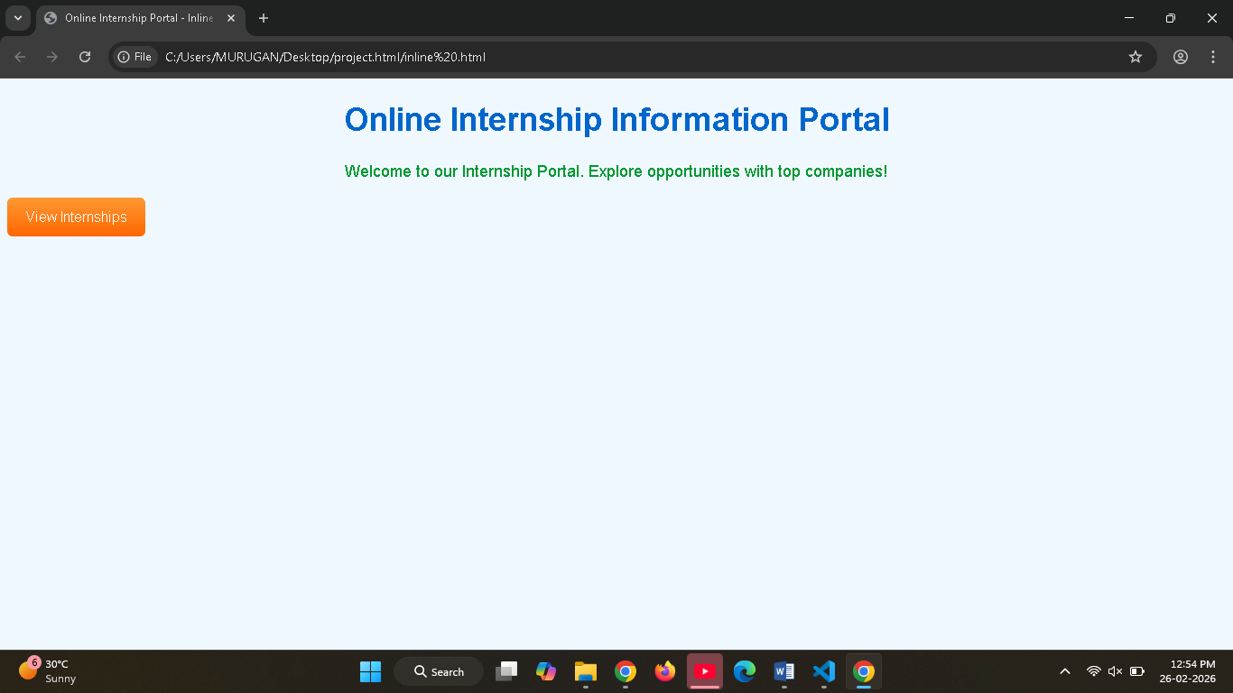
- Internal CSS applied through <style> section
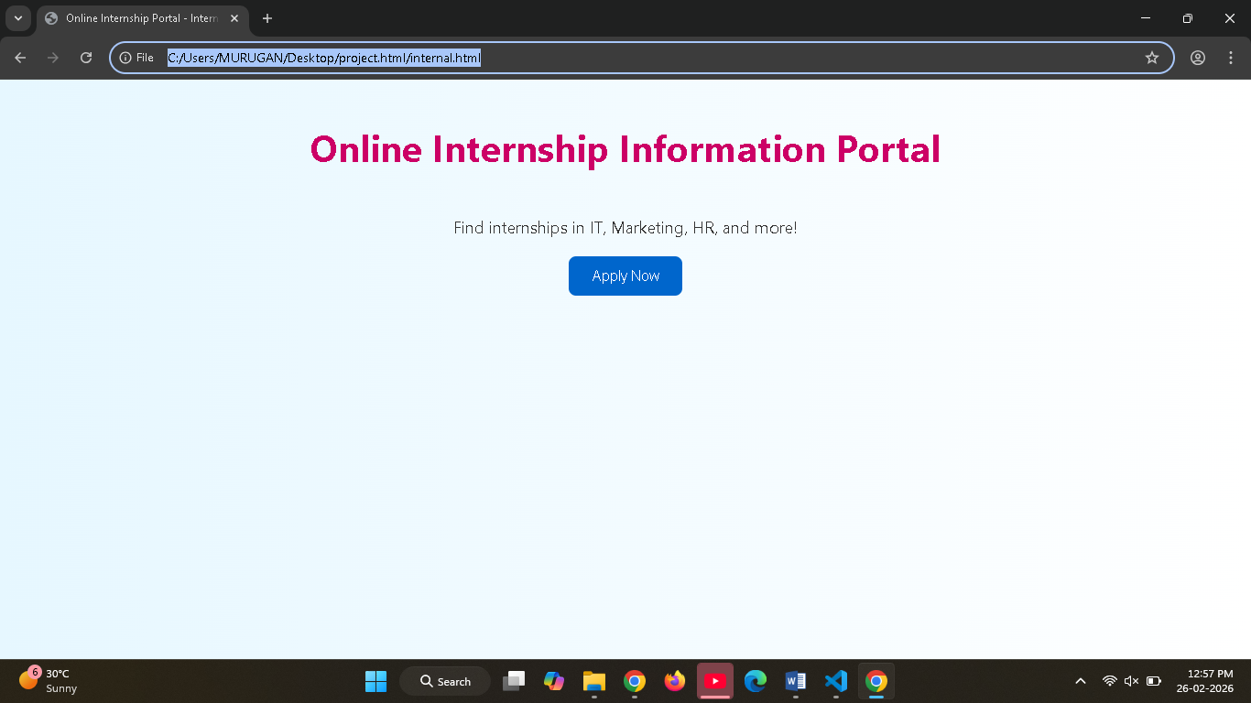
- External CSS applied through .css file
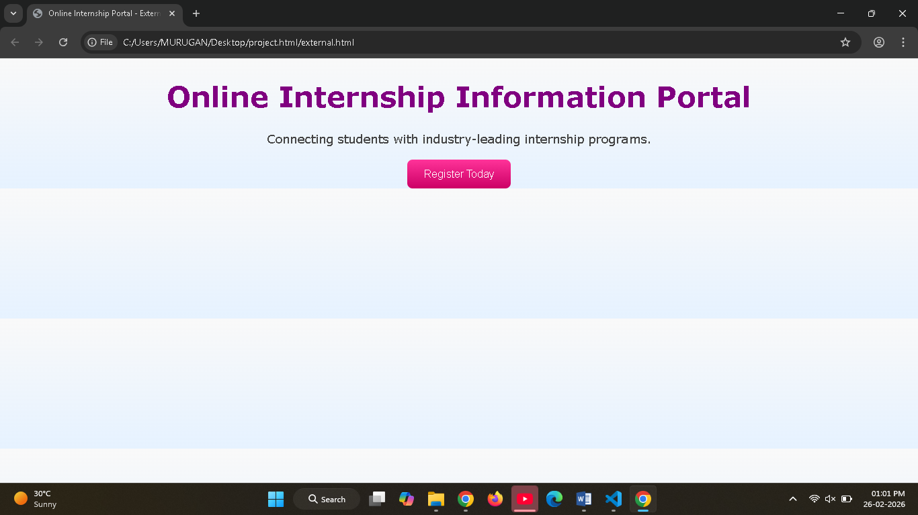

Result
Thus, the Online Internship Information Portal was successfully designed and demonstrated using Inline, Internal, and External stylesheets in CSS.

Program 2: Design Online Internship Information portal Web Page Using CSS Keyframe Animation

Aim
To design an Online Internship Information Portal web page and apply CSS keyframe animation for smooth card and text effects, making the portal visually appealing and engaging for students.

Theory
CSS Keyframe Animation is used to create animations by defining key points of style changes over time.
Syntax:
@keyframes animationName {
0% { }
100% { }
}

Steps / Procedure
- Create a new file internship_portal_animation.html.
- Write HTML structure with a portal title and internship details table inside a .card container.
- Add CSS in <style> for body, card, table, and text formatting.
- Define keyframe animations:
- slideIn → card slides in from top with fade-in.
- glowText → title glows with alternating colors.
- Apply animations to card and title using animation property.
- Save and run the file in browser to verify smooth card entry and glowing title effect.

Program Code

File: internship_portal_animation.html
<!DOCTYPE html>
<html>
<head>
<title>Online Internship Information Portal</title>
<style>
body {
font-family: 'Segoe UI', sans-serif;
background: linear-gradient(to right, #f0f8ff, #e6f2ff);
display: flex;
justify-content: center;
align-items: center;
height: 100vh;
margin: 0;
}

.card {
width: 500px;
padding: 25px;
background: white;
border-radius: 12px;
box-shadow: 0px 0px 20px rgba(0,0,0,0.25);
animation: slideIn 2s ease;
}

h2 {
text-align: center;
color: #0066cc;
font-size: 32px;
animation: glowText 2s infinite alternate;
}

table {
width: 100%;
margin-top: 20px;
border-collapse: collapse;
}

td {
padding: 12px;
border: 1px solid #ccc;
}

.label {
font-weight: bold;
background: #e0f7fa;
width: 40%;
}

/* Keyframe Animations */
@keyframes slideIn {
from {
transform: translateY(-60px);
opacity: 0;
}
to {
transform: translateY(0);
opacity: 1;
}
}

@keyframes glowText {
from {
color: #0066cc;
text-shadow: 0 0 5px skyblue;
}
to {
color: #ff3399;
text-shadow: 0 0 10px orange;
}
}
</style>
</head>

<body>
<div class="card">
<h2>Online Internship Information Portal</h2>
<table>
<tr>
<td class="label">Internship Title</td>
<td>Web Development Internship</td>
</tr>
<tr>
<td class="label">Company</td>
<td>Tech Solutions Pvt Ltd</td>
</tr>
<tr>
<td class="label">Duration</td>
<td>3 Months</td>
</tr>
<tr>
<td class="label">Location</td>
<td>Remote</td>
</tr>
<tr>
<td class="label">Eligibility</td>
<td>B.Tech / MCA Students</td>
</tr>
<tr>
<td class="label">Apply By</td>
<td>15 March 2026</td>
</tr>
</table>
</div>
</body>
</html>

Output
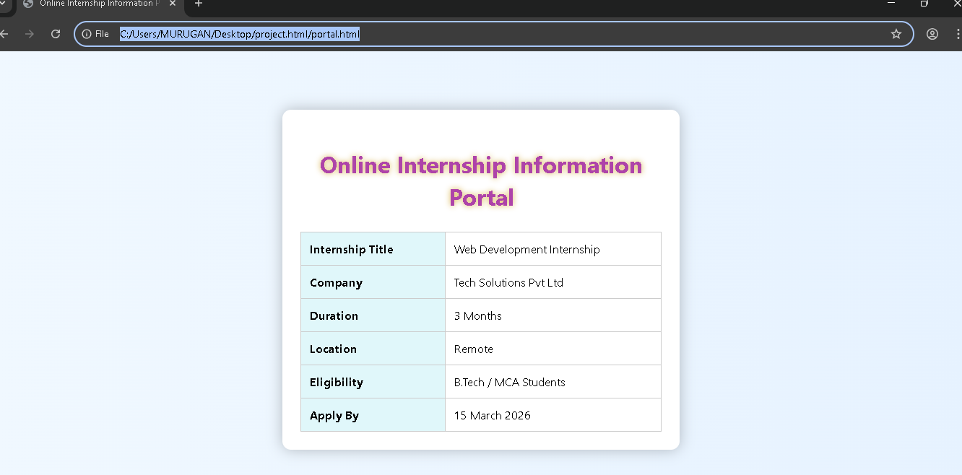

Result
Thus, an Online Internship Information Portal web page was successfully designed and CSS keyframe animation.

